**DAILY ONLINE ACTIVITIES SUMMARY**

|  |  |  |  |  |  |
| --- | --- | --- | --- | --- | --- |
| **Date:** | | **26/06/2020** | **Name:** | **JASLINE SHARON TAURO** | |
| **Sem & Sec** | | **4th sem, A Section** | **USN:** | **4AL18CS029** | |
| **Online Test Summary** | | | | | |
| **Subject** | **----** | | | | |
| **Max. Marks** | **----** | | **Score** | **----** | |
| **Certification Course Summary** | | | | | |
| **Course** | | DevOps ENGINEER | | | |
| **Certificate Provider** | | **AWS Educate** | **Duration** | | **4 hrs.** |
| **Coding Challenges** | | | | | |
| **Problem Statement:**  Given a list of numbers, write a Python program to count Even and Odd numbers in a List. | | | | | |
| **Status: EXECUTED** | | | | | |
| **Uploaded the report in GitHub** | | | **YES** | | |
| **If yes Repository name** | | | <https://github.com/jaslinesharontauro/Python-coding> | | |
| **Uploaded the report in slack** | | | **YES** | | |

Online Test Details: (Attach the snapshot and briefly write the report for the same)

Certification Course Details: (Attach the snapshot and briefly write the report for the same)

Coding Challenges Details: (Attach the snapshot and briefly write the report for the same)

CERTIFICATION COURSE DETAILS:

## Today I have continued the course “DevOps Engineer” by AWS Educate. In this course today I learnt about ‘Programming and Scripting’. Today I have completed two modules of this course, And I have also completed the assessment of this module.

## 

## 

WEBINAR DETAILS:

Today I have attended the webinar on “Cyber Security & Applications” by Professor Dr. Manjunath Kotari, HOD CSE department- AIET. The session was very interesting. There were two assessments conducted based on the webinar. The tests were of MCQ type.

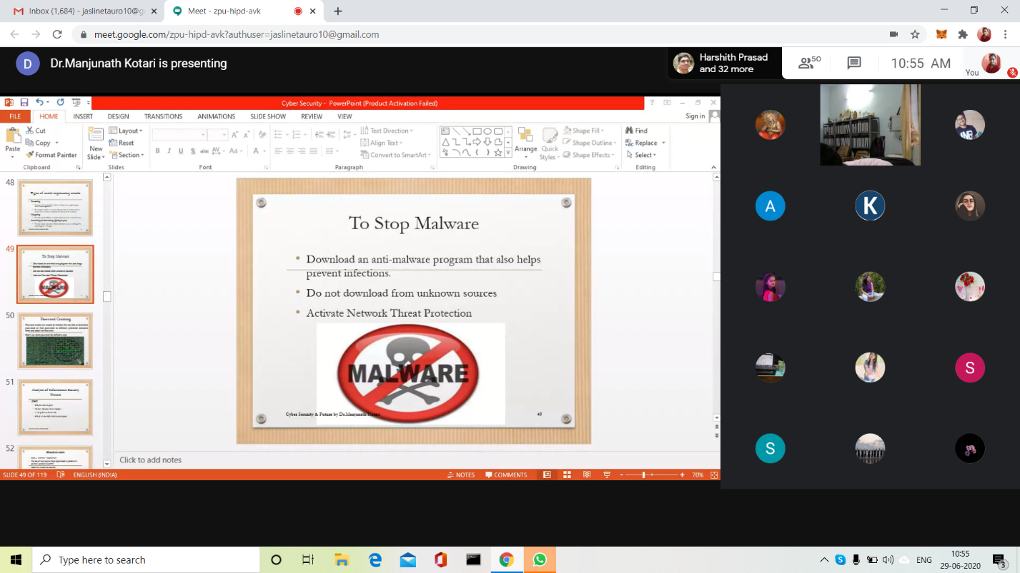

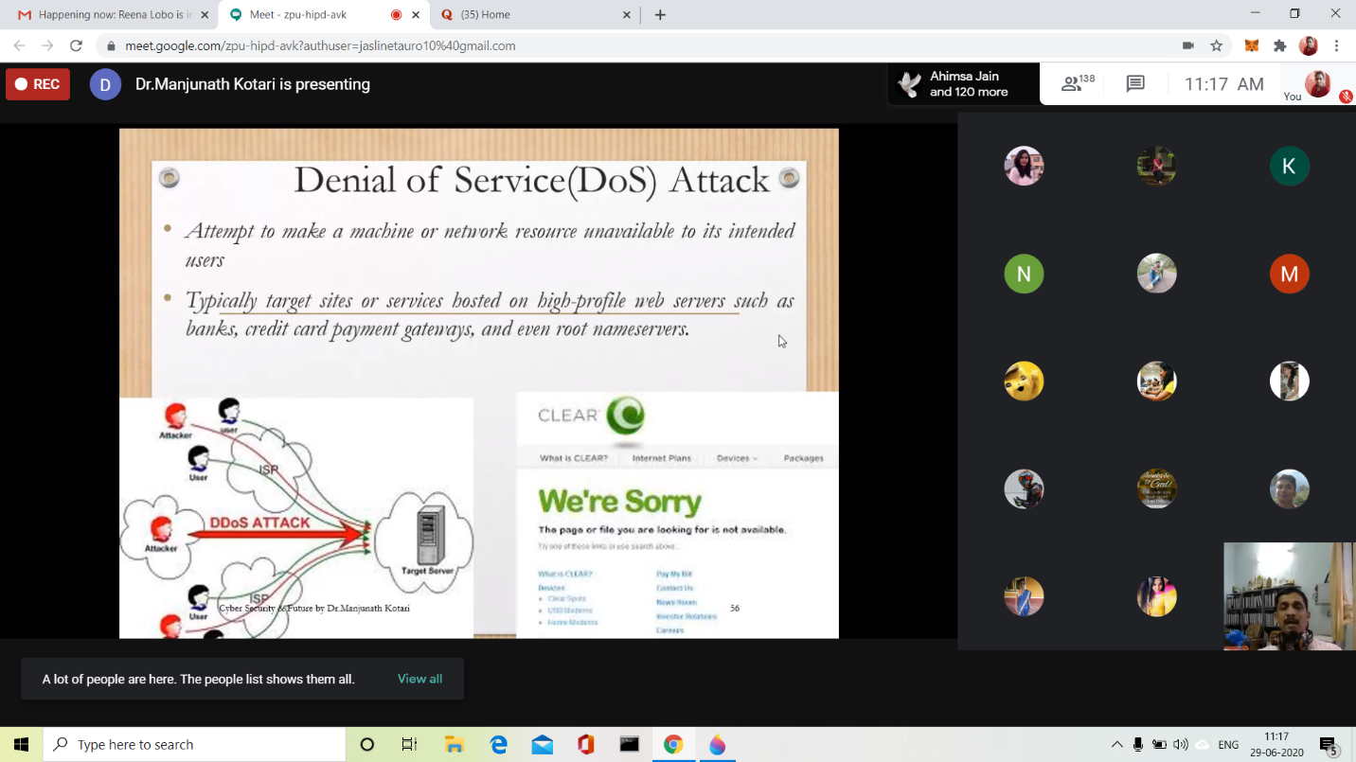

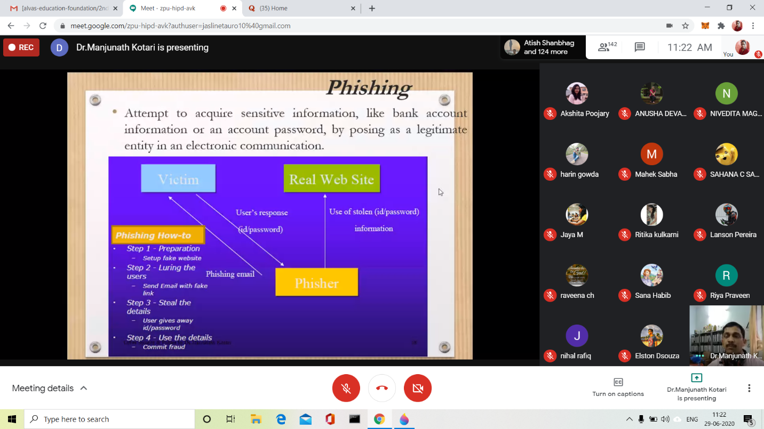

CODING CHALLENGES:

Problem Statement:

Given a list of numbers, write a Python program to count Even and Odd numbers in a List.

Example:

Input: list1 = [2, 7, 5, 64, 14] Output: Even = 3, odd = 2 Input: list2 = [12, 14, 95, 3] Output: Even = 2, odd = 2 Example 1:

Count Even and Odd numbers from given list using for loop Iterate each element in the list using for loop and check if num % 2 == 0, the condition to check even numbers. If the condition satisfies, then increase even count else increase odd count.

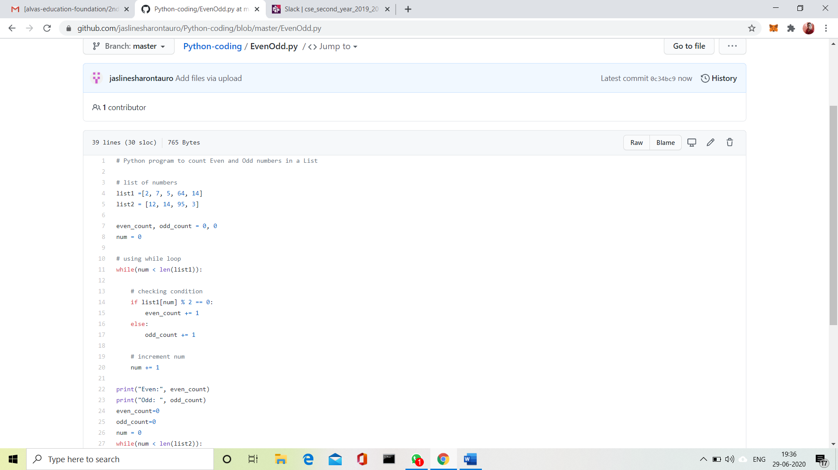

Solution Uploaded in GitHub.